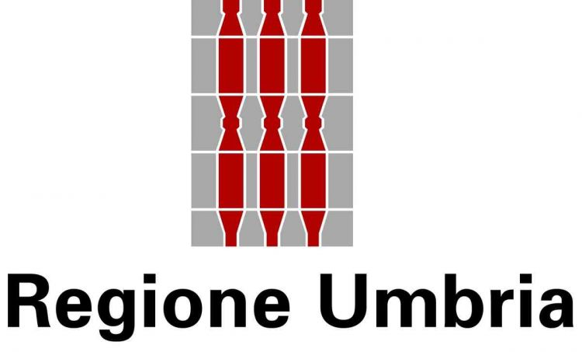
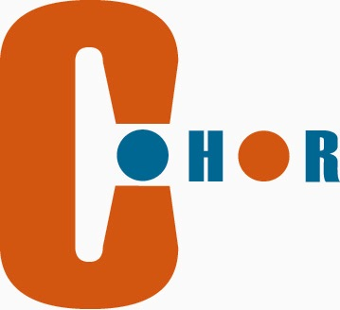

‘Youth in Action’ Programme
Call for proposals 2011
Call for Proposals EACEA/13/2011
Action 4.6 – Youth support systems - Partnerships

DEADLINE | 03.11.2011
MAIN AIM | To promote young people’s active citizenship in general and their European citizenship in particular.
GENERAL OBJECTIVES | To reduce the deficit level of information and communication among young people, to acknowledge young people about the importance of civic participation and in particular to remove the passive attitudes of non-involvement in civic activities. Activities performed within the project will focus on youth involvement in specific activities aimed mainly at developing civic skills, thus we intend to increase young people's sense of social utility and their desire to act in social change.
SPECIFIC OBJECTIVES | The main objectives of the project aims to:  - Fostering active citizenship among young people;  - Increasing awareness on the concept of democracy: democratic rights, decision making, mechanisms of functioning of democracy, civic responsibilities;  - Creation of a viable forms of interaction between young people from Umbria and other partners;  - Encouraging youth involvement in decision-making process at local level by promoting values and civic activities;  - Development of responsible behavior problems from their communities.
PRIORITY THEME | European citizenship, youth participation, and social inclusion of young with small possibilities.
ACTIONS | Training and Networking:  - Seminars  - Training Courses  - Partnership-building activities
TOTAL BUDGET | The maximum grant allocated to each project shall not exceed EUR 100 000.  Financial assistance from the Agency shall not be granted for more than 50% of a project’s total eligible expenses.
PARTNERS COOFINANCIG | 50% (50.000 euros; with 4 partners it is 12.500 each)
DURATION | 24 MONTHS
PARTNERS | Projects must involve partners from at least four different Programme Countries (including the applicant organisation), of which at least one is a Member State of the European Union  Partner searched:  A public body at regional or local level
Applicant | Umbria Region  Anna Lisa Lelli  alelli@regioneumbria.it  info@fpeurope.com
Co-organising partner | Consorzio Co.Hor  Strada Santa Lucia, 8 -06125 Perugia  Enrico Libera

